# Lab-5-2: Checkpoint

# Objectives

* Gather a basic understanding of and experience with Microsoft PowerShell



# Preparation

1. Open the PowerShell ISE (To do that type ‘powershell’ in the search field on your workstation
2. Select Windows **PowerShell ISE**). You can also perform this lab in the basic PowerShell environment (Windows **PowerShell**), but you may be missing the code completion facilities of the Interactive Scripting Environment (ISE).
3. You can also pin it to your taskbar for ease of access in future.

# Exploring PowerShell

Solve the following tasks based on the **integrated help** (get-help), **lecture slides** and PowerShell **online reference**.

**Write down the commands you used to achieve the tasks.**

1. Run FileModifier.jar in live mode and use robocopy to generate log file in the following format:

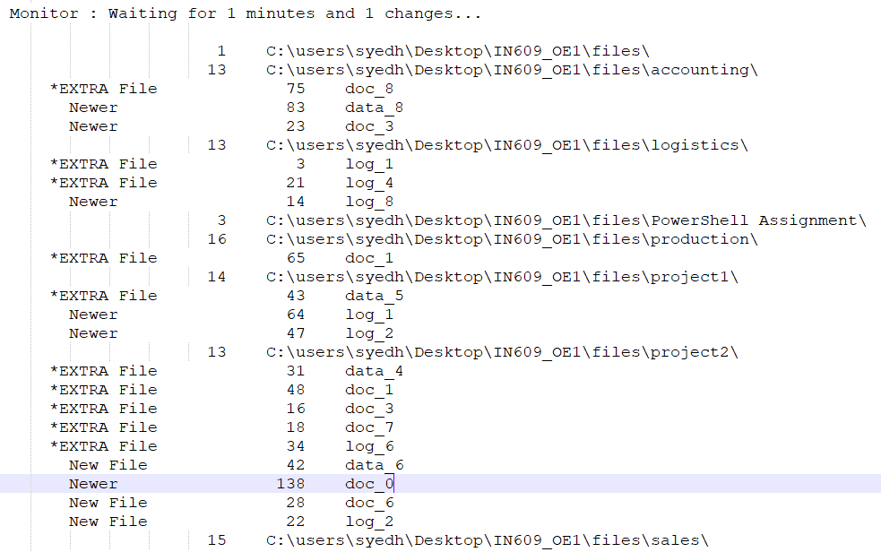

function BackupDirectory{

param([string]$source, [string]$destination, [string]$file, [string]$logs, [int]$timer, [int]$changes)

robocopy $source $destination /b /mot:$timer /tee /e /im /is /it /x /NP /ns /mir /log+:$logs /njh /njs /copy:dat /MT:8 /w:10 /xf "FileModifier.jar"

}



1. In the above log file, identify the deleted files and new files. Write a script to create the following logfile that only contains the file name, the operation (deletion/ creation):

DELETED doc_1

CREATED doc_5

function Read{

param([string]$source)

$content = Get-Content $source

Get-Content $source | Where-Object {$_ -like "*EXTRA File*"} | ForEach-Object {

$newline = $_ -creplace "\*EXTRA", "DELETED" -replace "\s+", "" -creplace "File", " "

$newline | Out-File -FilePath C:\$env:HOMEPATH\Desktop\backuplogs.txt -Append

Write-Host $newline

}

Get-Content $source | Where-Object {$_ -like "*New File*"} | ForEach-Object {

$newline = $_ -replace "New File", "CREATED" -creplace "\s+", " "

$path = $newline -split "\files"

$newline | Out-File -FilePath C:\$env:HOMEPATH\Desktop\backuplogs.txt -Append

Write-Host $newline $path

}

}

Read "C:\$env:HOMEPATH\Desktop\Week 5\backuplogs.txt"